PROJECT 1: DEPLOYING WEBSITE /APPLICATION ON AWC EC2 INSTANCES

STEP 1: create VPC

Browse AWS console login and sign in, in AWS console search VPC in VPC dashboard you get yours VPC click on that and click create VPC, give name to VPC here the name given as kruthi VPC then click create VPC.

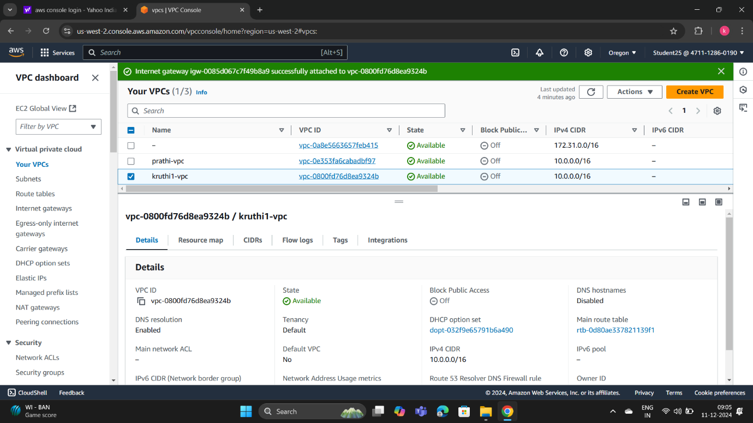

STEP 2: Create internet gateway

In VPC dashboard click on internet gateway and click on create internet gateway then give name to it here the name given as kruthi-ig

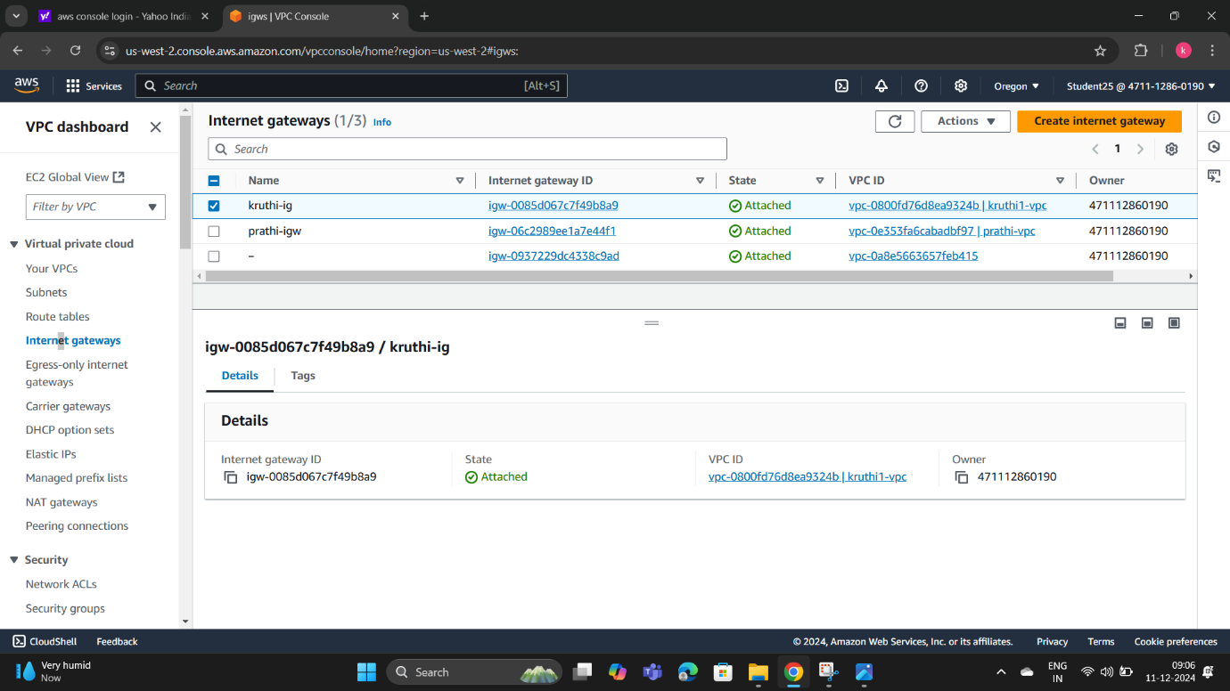

STEP 3: Create subnets->under the VPC dashboard select subnets->click on create subnet->create two public subnets here the name given as kruthi public 1 and kruthi public 2->choose availability zone->choose subnet CIDR block as 10.0.1.0/24.->create subnet.

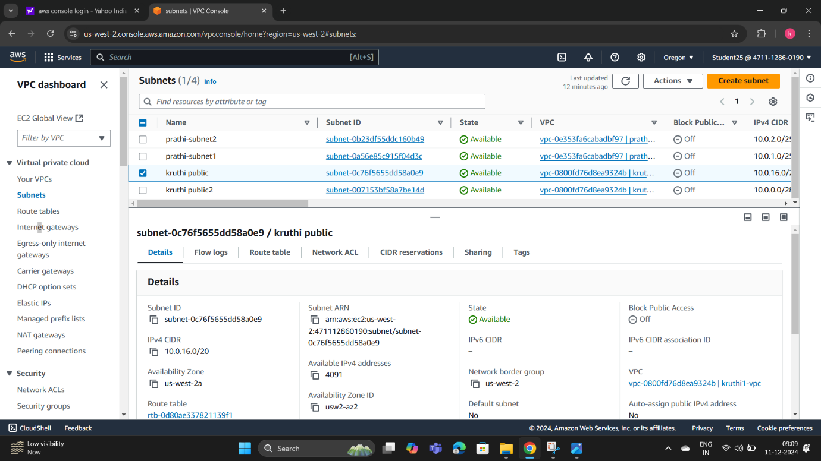

Public subnet 2

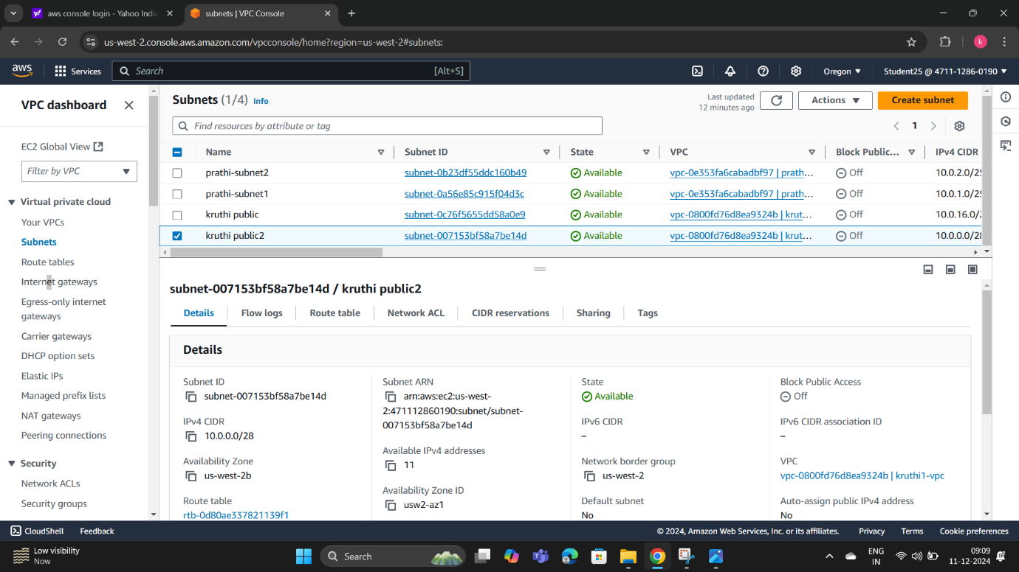

STEP 4 : Create route tables->under virtual private cloud select route table->give name to route like kruthi-rt->after creating route table click on edit RT add routes(0.0.0.0)->select destination and target as internet gateway->click on save changes->click back to route table->click on subnet association->edit subnet association->select both subnets->save changes.

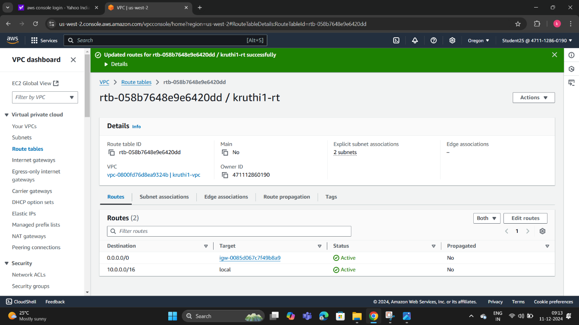

STEP 5: create instances->search EC2 on AWC console->click on EC2->select instances->launch instances->give name here kruthi1-server->select amazon linux->create key pair->in network setting click on edit->select your VPC->make auto assign public->enable->give security group name->click on view all instances.

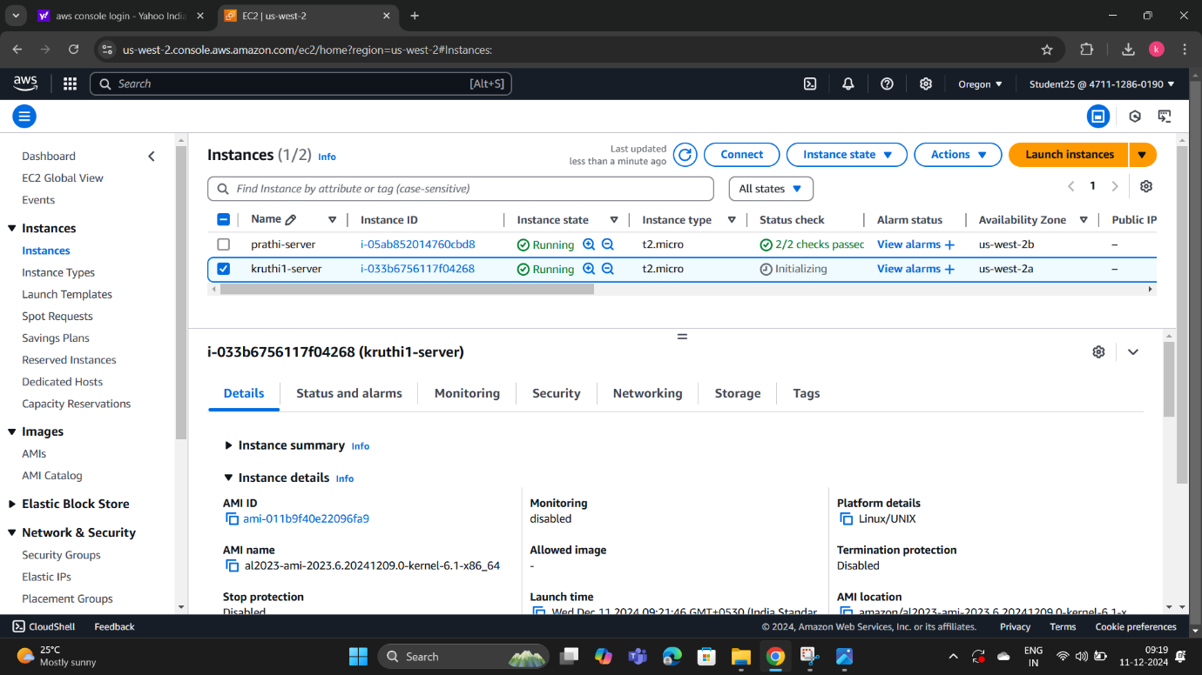

STEP 6 : Connect to instances->copy the ssh example and paste to command promt

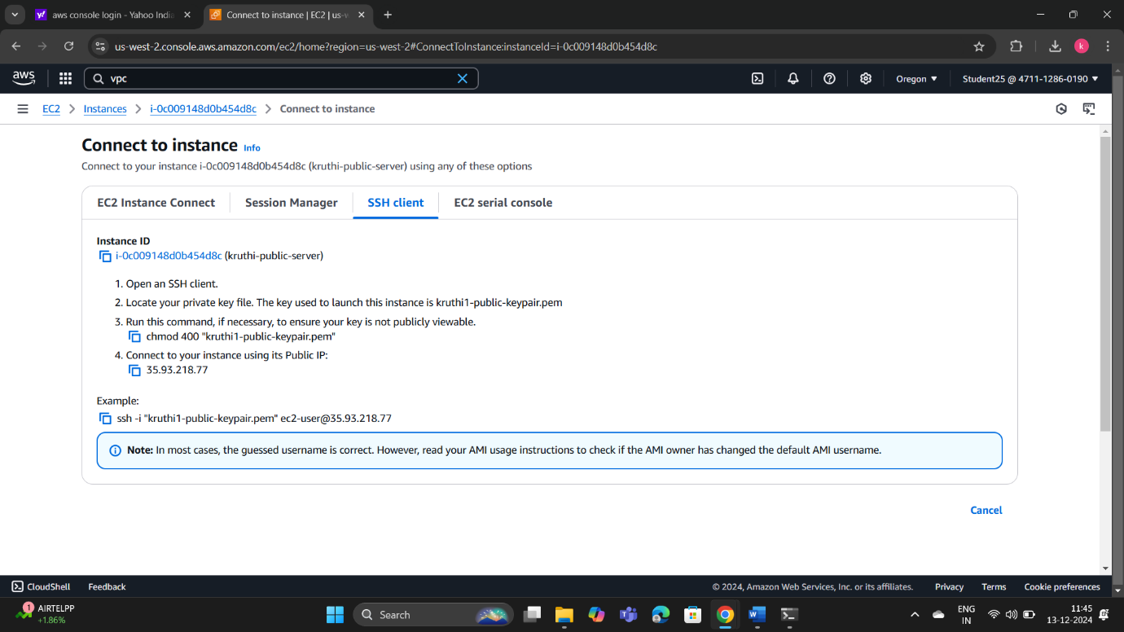

STEP 7: Command prompt->enter cd downloads->paste ssh here what you copied from instances->enter yes->sudo su->cd->vi index.html->insert mode->copy and paste keypair from the downloads->enter.

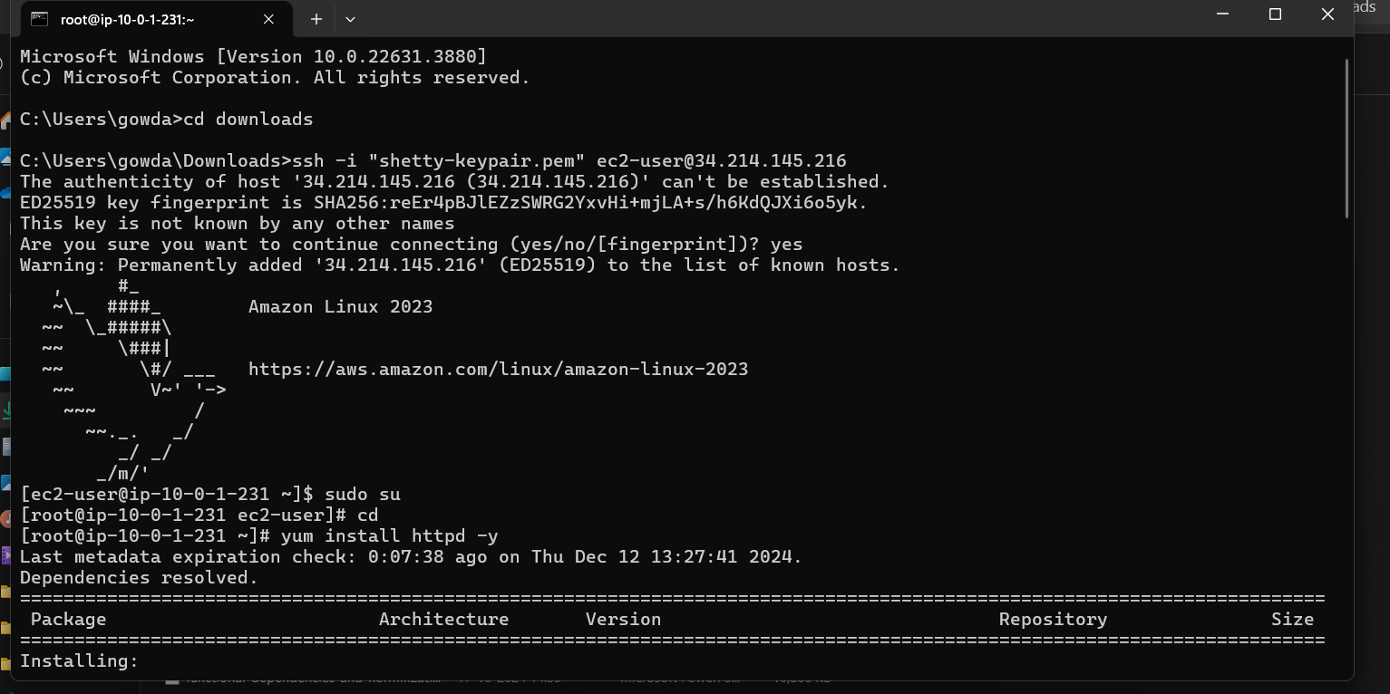

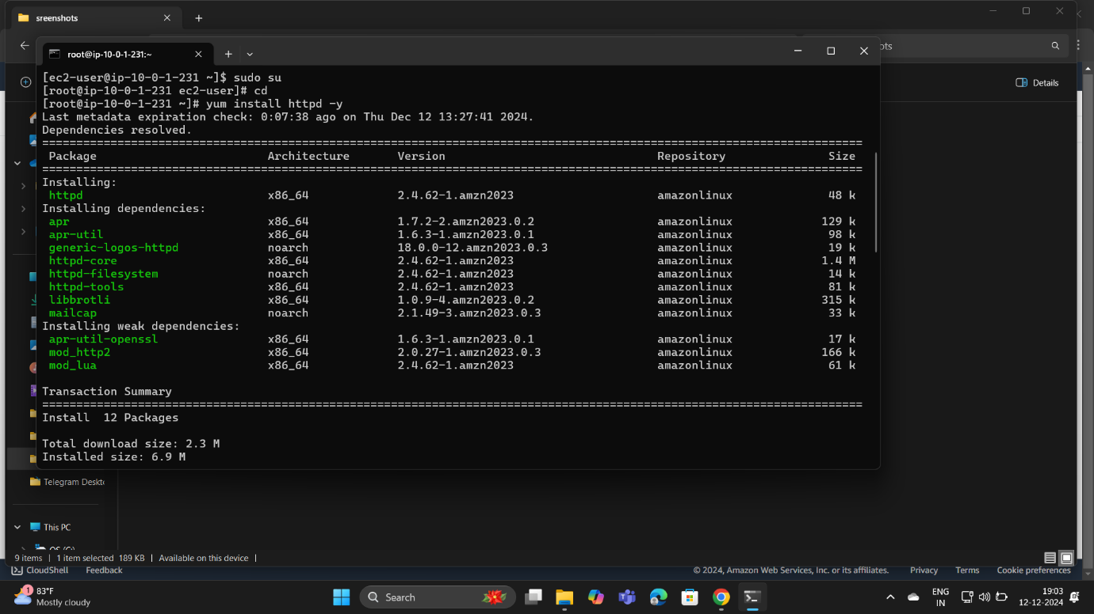

STEP 8: final result

